**Coding Test-2: Python (List, Dictionary, String and Conditional)**

**Duration: 60 minutes (Start: 1:40, End: 2:40, Submission: 2:45)**

**File Name: A1_CT_2_ID**

**Total Marks: 20**

1. Write a program to check Leap year. [5]

Following is pseudo code:

if year is divisible by 400 then is_leap_year

else if year is divisible by 100 then not_leap_year

else if year is divisible by 4 then is_leap_year

else not_leap_year

1. Given a string of length 12, divide the string into 4 parts of length 3. Then swap the first part with the last part. Output the final string. [5]

Example:

Given String: “ABCDEFGHIJKL”

4 parts of the string: “ABC”, “DEF”, “GHI”, “JKL”

Swap the first and last part: “JKL”, “DEF”, “GHI”, “ABC”

Output: ‘JKLDEFGHIABC’

------------------------------------------------------------

Sample:

Input: “ABCDEFGHIJKL”

Output: ‘JKLDEFGHIABC’

1. Suppose you are going to start a Django Project with a group of 5 members. Now, you need to store the information (Name, ID, CGPA, Email_Address, and Contact_no) about the group members in some variables. Choose the appropriate data type where one can search a member effectively. [5]
2. Choose appropriate variables to store the following information where anyone can search with Student’s name. [5]

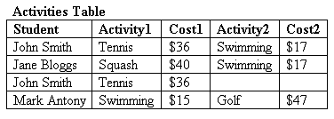

**OR**

1. Choose variables of appropriate data type to store the information of the following table in a way that if someone inputs the EmployeeID, it will show all the information of that Employee. [5]

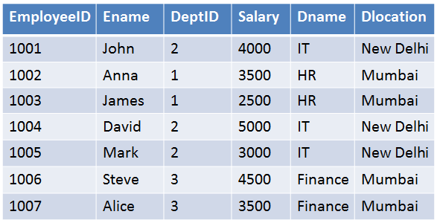

Input:

1002

Output:

Ename: Anna, DeptID: 1, Salary: 3500, Dname: HR, Dlocation: Mumbai